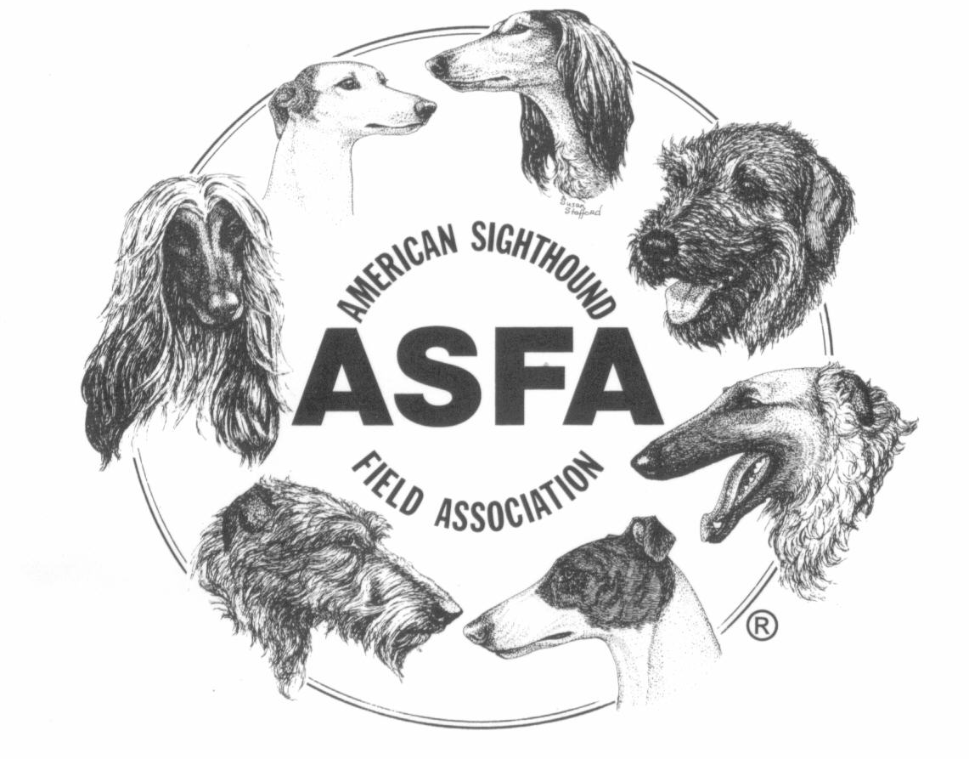ASFA FIELD TRIAL SECRETARY REPORT

AMERICAN SIGHTHOUND FIELD ASSOCIATION

Host Club: Region:

Field Trial Chairman name:

FTS e-mail address:

Trial Date: Trial Location:

Please circle the response, and answer the questions below:

- Were any judges changed from the approved premium list? Yes No
If yes, list the breed judging assignments that may have been changed as well. (Include a copy of the corrected premium list.) Each judge is responsible for notifying the Judges Chair of any change to their assignment at judgeslic@asfa.org.

- Were there any other significant changes to the approved premium list? Yes No
(If so, please include with the corrected premium.)

- Were any Open or Veteran dogs first time entrants? Yes No
Is yes, please include a copy of the registration form, the certification form, and the entry form.
NOTE: Registration form is not required if the dog had previously run in singles in an ASFA trial.

- Were any Singles first time entrants? Yes No
Is yes, please include a copy of the registration form and the entry form.

- Were any of entries marked for working off a dismissal? Yes No
If yes, please include the entry forms for those dogs.

- Were any of the entries marked for change of information? Yes No
This could be titles of the hound added, or owner information changes.
NOTE: If change in ownership, a copy of the new registration form is required.

Please continue to Page 2 and complete one entry grid for each day of the trial.

- Entries: (One form per day of trial)
Club: |  |  |  |  | Date:
BREED | OPEN | FCH | VETS | TOTALS | BREEDER | KENNEL | BENCH | TOTALS
Afghan Hounds
Azawakh
Basenji
Borzoi
Cirneco dell ’Etna
Greyhounds
Ibizan Hounds
Irish Wolfhounds
Italian Greyhounds
Peruvian Inca Orchid
Pharaoh Hounds
Rhodesian Ridgebacks
Saluki
Scottish Deerhounds
Silken Windhounds
Sloughis
Whippets
Provisional
Singles
LCI Large
LCI Small
LCI SH (Sighthound Mix)
Totals Breed Entries

TOTAL Breed Entries @ $4.00 per capita =
($3.50 if records submitted electronically) $

TOTAL Special Stakes (Kennel, Breeder, Bench) @ $1.00 per capita = $
Records Fee per trial @ $15.00 $
Per capita paid by Check (included with records) Amount - $
Per capita paid by Pay Pal Amount - $
PayPal Transaction ID (if used):

